**GPS Tracking System**

**ACKNOWLEDGEMENT**

We would like to express our special thanks of gratitude to our Guide – **Prof. Amit Kumar** who gave us the golden opportunity to do this wonderful project on the topic “**GPS Tracking System**”, which also helped us in doing a lot of Research and we came to know about many things We are really thankful to them. Secondly we would like to thank our parents and friends who helped us a lot in finishing this project within the limited time.

**CONTENTS**

**Serial No Title Page no**

1. **INTRODUCTION………………………….** 
   1. PURPOSE
   2. SCOPE
   3. OBJECTIVE
   4. LITERATURE STUDY

1.4.1. COMPONENTS

1.4.2. POSITIONING

1.4.3. NAVIGATION

1.4.4. TIMING

1.4.5. APPLICATION

1. **SYSTEM ANALYSIS…………………………………..**

2.1. SPECIFIC REQUIREMENT

2.2. HARDWARE DESCRIPTION

2.3. EMBEDED SYSTEM ARCHITECTURE

2.4. Software Requirement Specification

1. **DESIGN…………………….........................**

3.a. Use case Template

3.1. SRS (Software Requirement Specification)

3.1.1. Purpose

3.1.2. Scope

3.1.3. System Feature

3.1.4. Functional Requirement

3.1.4.1. Parse Location

3.1.4.2. Send Location

3.1.4.3. Update Log

3.1.4.4. View Log

3.1.4.5. Delete Log Entry

3.1.4.6. Show Location

3.1.5. Non-Functional Requirement

3.2. OBJECT RELATIONAL MODEL

3.3. SEQUENCE DIAGRAM

3.4. ANALYSIS CLASS DIAGRAM

3.5. ACTIVITY DIAGRAM

**5. TESTING……..**

**6. OUTPUT AND REPORT………………………**

**7. CONCLUSION &**

**FUTURE ENHANCEMENT…………………..**

**8. BIBLIOGRAPHY ………………………………**

1. **INTRODUCTION:**

A **GPS tracking** unit is a device that uses the [Global Positioning System](http://en.wikipedia.org/wiki/Global_Positioning_System) (**GPS**) to determine the precise location of a vehicle, person, or other asset to which it is attached and to record the position of the asset at regular intervals. The recorded location data can be stored within the tracking unit, or it may be transmitted to a central location data base, or internet-connected computer, using a [cellular](http://en.wikipedia.org/wiki/Cellular_network) ([GPRS](http://en.wikipedia.org/wiki/GPRS) or [SMS](http://en.wikipedia.org/wiki/SMS)), [radio](http://en.wikipedia.org/wiki/Radio), or [satellite modem](http://en.wikipedia.org/wiki/Satellite_modem) embedded in the unit. This allows the asset's location to be displayed against a map backdrop either in real time or when analysing the track later, using **GPS tracking software**.

**1.1. Purpose:**

The purpose of this case study is to describe the cab booking system which provides the cab booking details, billing, and cancellation on various types of booking namely.

A wide range of tracking systems has been developed so far tracking vehicles and displaying their position on a map, we can also use the system that has been developed to tracks the mobility of a human being. Now a day's tracking a person's mobility has become a crucial issue these days be it tracking a criminal came on payroll or a detective going to detect a case or any other utility.

**1.2. Scope:**

Passenger Revenue Enhancement.

Improved and Optimized service.

Global Positioning System has numerous applications. The earliest application was military. Boaters were the first civilians to use GPS extensively for navigation, as dead reckoning is prone to error. Many high-end cars have a GPS navigation system which serves much the same purpose as a marine GPS. Some athletes are turning to GPS to track speed and distance. A few digital cameras have a GPS receiver which records the location where the picture was taken. So far, I've listed only one-way applications. Two-way applications include cell phones when calling the emergency number and vehicle tracking.

**1.3. Objective:**

## The global positioning system, more commonly referred to as GPS, is a radio frequency navigation system operated by the U.S. Department of Defense. GPS was originally developed for military purposes, but has since become available to non-military personnel worldwide as well. According to the National Executive Committee for Space-Based Positioning, Navigation and Timing, the objectives of GPS are to provide accurate positioning, navigation and atomic timing services on a

## continuous and free basis.

## 1.4 Literature Survey:

## 1.4.1. Components:

GPS is comprised of three main segments: space, control and users. The space segment consists of a constellation of U.S. satellites, placed so that at least three satellites are positioned above the horizon from any point on earth. PNT states that as of October 2009, 35 GPS satellites were in use. The control segment includes monitoring stations located worldwide charged with monitoring the GPS system. The user segment is made up of GPS receivers.

**1.4.2. Positioning:**

GPS provides the user with a precise location by utilizing radio frequencies. The GPS receiver translates the information from at least three GPS satellites to provide the user with a two-dimensional location of latitudinal and longitudinal position on earth. If a fourth satellite is available, then the receiver can provide the user with three-dimensional location information, which includes altitude in addition to latitude and longitude.

**1.4.3. Navigation:**

Navigation enables a user to process his current location based on GPS data and travel to his desired location, also based on accurate GPS data. Any user with a working GPS receiver can navigate to a particular destination, whether traveling on foot, by automobile, by airplane or by ship. GPS navigation is even accurate underground.

* + 1. **Timing :**

Time is the fourth dimension that GPS is set up to provide, by synchronizing each GPS receiver to the GPS satellites to provide accurate time to the user. The time is accurate to one hundred-billionth of a second. GPS receivers are able to perform this function because each GPS satellite includes several atomic clocks.

* + 1. **Applications :**

In addition to military use, GPS has multiple civilian applications. GPS has enabled many businesses to operate more efficiently and effectively by providing accurate time. Commercial and public transportation companies can save time and money by routing their carriers to less-congested areas. The average traveller can use GPS to find the nearest coffee shop, book store or gas station. GPS also can be used to enhance survival rates in search-and-rescue missions. The possibilities are endless, and as the use of GPS technology increases, so will the potential applications.

**2. SYSTEM ANALYSIS:**

**OBJECTIVE:**

The objective of this chapter is to study the specific requirement hardware, software design and its function.

**2.1. SPECIFIC REQUIREMENT:**

Arduino can sense the environment by receiving input from a variety of sensors and can affect its surroundings by controlling lights, motors, and other actuators. The microcontroller on the board is programmed using the [Arduino programming language](http://arduino.cc/en/Reference/HomePage) (based on [Wiring](http://wiring.org.co/)) and the Arduino development environment (based on [Processing](http://www.processing.org/)). Arduino projects can be stand-alone or they can communicate with software running on a computer (e.g. Flash, Processing, MaxMSP).

The boards can be [built by hand](http://arduino.cc/en/Main/ArduinoBoardSerialSingleSided3) or [purchased](http://arduino.cc/en/Main/Buy) preassembled; the software can be [downloaded](http://arduino.cc/en/Main/Software) for free. The hardware reference designs (CAD files) are [available](http://arduino.cc/en/Main/Products) under an open-source license, you are free to [adapt them as](http://arduino.cc/en/Main/Policy) per yours project requirement.

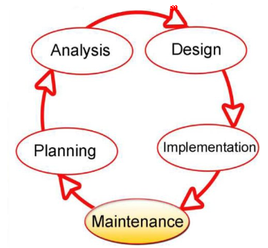

# 2.1.1 Software Requirement Specification :-

2.1.2 **Software interface**

Front end -> C++

Back end -> MS-Access

**FULL TAXI DISPATCH SYSTEM web-based.**  
  
 Will include:-  
  
- Geolocalisation ( Client mode on Dreevo , Iphone, Android, etc...)

Geolocalization services are provided directly by the satellite to the employees of the company which are provided with the GPS enabled cell phones so that they can track, heck and automize the services of the cabs.  
- Track via GPRS all the taxis equiped with Dreevo ( at least )

All the cabs are fitted with automated GPRS system and are connected round the clock with the main server for their location information.  
  
- Store in a Database all the customers with ID, Address, Telephone, X, Y.

The database is maintained with the customer id, address and telephone numbers of all the customers.  
- Search the closest available taxis to a specific address of the a Customer (based on a Google Maps Cartography )

Service provider can search the closest available cab which is nearer to the customers address and the service is based on a technique based on google maps called cartography.  


- Assign a Service to the closest available taxi and change its status to busy, available, soon arrived, off duty, etc....

When a cab is found then operator must assign its status to busy, available, soon arrived, off duty, etc....  
- Keep track of the Service until it finishes and receive approximate distance and time elapsed.  
- Has a dedicated module to introduce new customers to the database, this is done through address search.  
- Send the Service via GPRS and receive the information from the taxis via GPRS. ( And SMS to ! )  
- Integrated function for payment onboard and invoice system on the web-interface.  
  
- The solution must have a customer web-page, that the customer can make its own booking on the site, and can be seen by the operator and the screen with automatic dispatch to available cars and with alert ( SMS, SMTP, GRPS...Etc...)  
  
- The solution must have an administration tool , for system  
- The solution must have an Operator Command Panel to lead the dispatch and make the regulation of the taxi traffic, with CHAT and IM in direct with the drivers on the road ( through the client : Dreevo, Iphone, Android...)

**3.** **DESIGN:**

There are already a lot of applications which use the geo-positioning. Garmin, one of the famous GPS manufacturer, proposes maps of almost every countries in the world ready to be download into their panel of GPS devices. Different kind of applications for different kind of public: road maps and tracking, topologic maps for technical job like geologist (for instance), light’s map for pilots, etc.

Also it exist, for mountain activities like free ride, hacking, those automatic signaling systems which switch on as soon as the rider get caught by an avalanche for example. It transmits a radio signal to the closest relay and indicate the exact position of the victim. It helps for the search and often save lives. The portable Tom-tom GPS proposes a full navigation system with vocal indication.

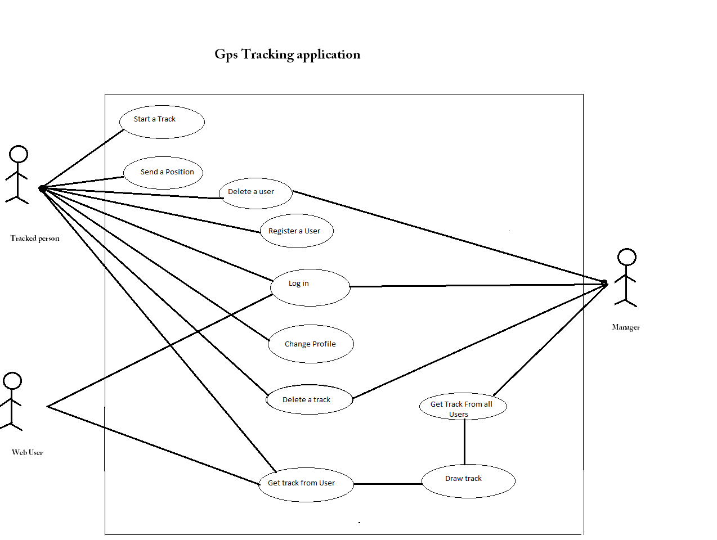The list of geo-positioning applications is huge and a simple search on the Internet gives hundred web sites talking about the topic.

**USE CASE Diagram:**

CAB BOOKING SYSTEM

SOURCE/DESTINATION

DATE/TIME

TYPE OF CAB

FARE/KM & TOTAL FARE

PAYMENT OPTION

USER

ADMINISTRATOR

CUSTOMER NAME,EMAIL-ID NEME,ADDRESS AND MODE OF PAYMENT

REPORT

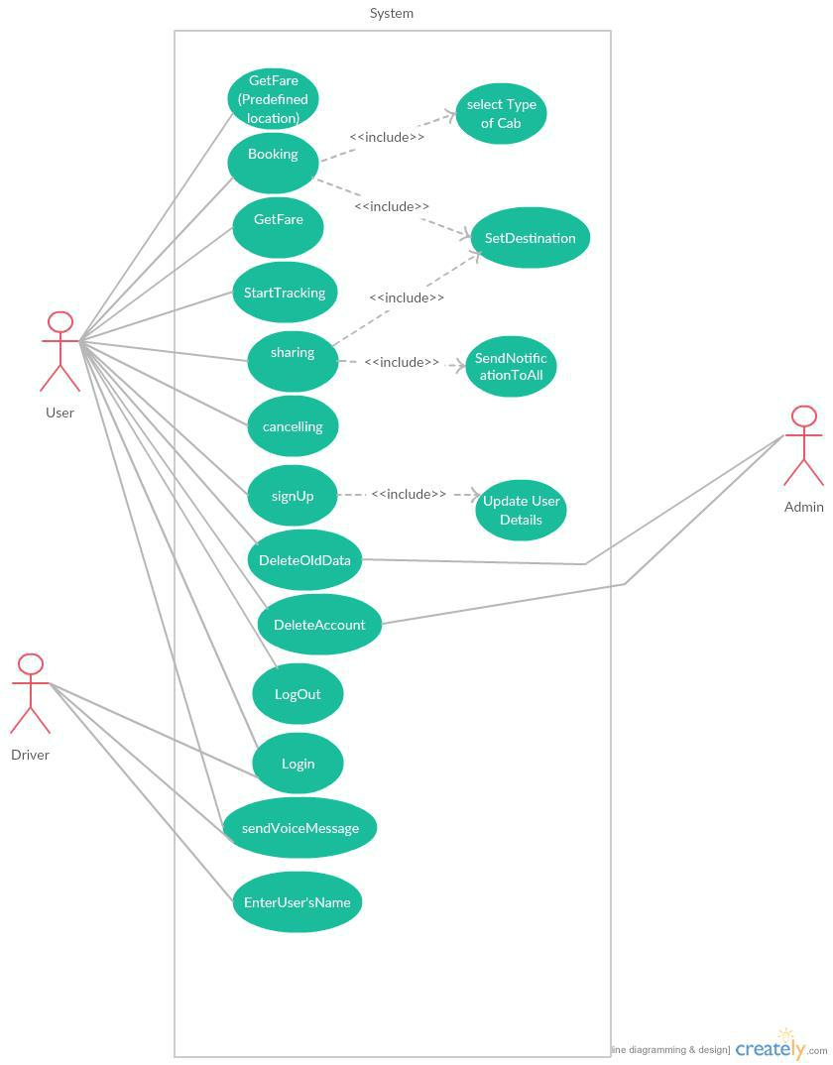

# 3.a Use Case Template:-

1. **Source / Destination** :- Use case specification
   1. Brief Description :- The main use of this use case is to provide the details about source and the destination of the user of the cab.

**Flow of Events** :-

* 1. **Basic Flow** :-

1. User books a cab by providing the details of source and destination.

2. Booking clerk check the database.

1. On successful traveller makes the booking of the cab.

**1.3 Pre conditions :-**

The traveller should have a cab for a destination place.

**1.4 Post conditions :-**

The database must be modified after the booking transaction takes place.

**2. Date / Time :-** Use case specification

**2.1 Brief Description :-**

The main purpose of this use case is to know details about the number of cabs available at that particular date and time.

**Flow of events** :-

**2.2 Basic Flow:-**

1. User checks the availability on website.

2. On successful completion of transaction user makes booking.

**2.3 Pre condition**

The traveller should have a cab booked for destination place.

**2.4 Post condition**

The booking database must be modified.

Figure -2

**3.1. SRS(Software Requirement Specification):**

* + 1. **Purpose**

The Software Requirement Specification (SRS) will provide a detailed description of the requirement for GPS Tracking System . This SRS will allow for a complete understanding of what is to be expected of the GPS Tracking System to be constructed. This SRS will used for constructing.

* + 1. **Scope**

The GPS tracking system will enable a user to track online any object attached with tracking device through a browser , for security, location, route planning purposes .

* + 1. **System features** 
       1. The system should provide current location of the object being tracked at request.
       2. The system should log position of the object being tracked at a fixed interval of time.
       3. The system should let admin to delete or edit location log .
    2. **Functional Requirement**

**3.1.4.1. Parse Locations**

Description : This function will run on the device at every fixed interval of time to read the input from GPS receiver and get the location data.

Input : NMEA String from the GPS receiver.

Output: Location data and time stamp.

**3.1.4.2. Send Location**

Description : This function runs on the device to send the location data and time stamp to the server. On receiving the time stamp from the server it knows that the location data has been logged for the said time

Input: Location data and timestamp .

Output: Time stamp.

**3.1.4.3. Update Log**

Description : Stores the location data received to the table.

Input : Location data and timestamp

Output : Time stamp of the updated entry .

**3.1.4.4. View Log**

Description : Function to view the log.

Input : Request to view the log .

Output : Logged location data.

**3.1.4.5. Delete Log Entry**

Description : Allows admins to delete logged entry

Input : Time stamp of the entry.

Output : Entry deleted acknowledgement .

**3.1.4.6. Show Location**

Description : Allows user to get current location of the device or the location at a given time.

Input: Time stamp

Output : Location at the given time

**3.1.5.1 Type of Cab (UC-1):**

Clients may see the taxi timing at a date their name and their kind of booking.

**3.1.5.2 Booking (UC-2):**

In the wake of checking the quantity of taxicab accessible, the clients books a taxicab or number of taxis as indicated by their necessities.

**3.1.5.3 Sharing (UC-3):**

In the event that a client need to impart a taxi to different understudies/personnel they can give their points of interest (time of take-off, area, and sort of taxicab) and a notice will be sent to other application clients. In the event that other need to share they will contact client.

**3.1.5.4 Destination (UC-4):**

User can input their destination and they can see their distance from current location.

**3.1.5.5 Cancelation (UC-5):**

In the event that the client need to cross out the taxicab then 10% of the sum for every individual is deducted if the booking is wiped out before 30 mins of the administration time.

**3.1.5.6 Get Fare (Predefined) (UC-6):**

After reserving the required cab, the user can see the fares of some preset destinations.

**3.1.5.7 Get Fare (UC-7):**

All out expense for an area can be ascertained by giving current area and goal.

**3.1.5.8 Send Notification (UC-8):**

Whenever a user request to share a cab, a notification is send to all passengers travelling in that cab.

**3.1.5.9 Enter User (UC-9):**

App user will have to provide their details while making their id.

**3.1.5.10 Update User (UC-10):**

User/driver can edit their profile and update information any time they want.

**3.1.5.11 Login (UC-11):**

Each client need to login into their record to begin booking/sharing taxicab. Drivers likewise need to login.

**3.1.5.12 Sign UP (UC-12):**

Administrator has power to acknowledge the enrolment of client. Driver will likewise need to info client name before giving taxi administration.

**3.1.5.13 Start Tracking (UC-13):**

This function will run on the device at every fixed interval of time to read the input from GPS receiver and get the location data.

**3.1.5.14 Log out (UC-14):**

Client will have alternative to log out after culmination of his assignment.

**3.1.5.15 Delete Account (UC-15):**

Driver can choose to delete old document of user from their app. Admin has authority to delete user account, from the server.

**3.1.5.16 Delete Old Data (UC-16):**

Allow admin to delete logged entry.

**4.1.17 Send Voice Message (UC-17):**

A voice message will be send to driver and guard as soon as a cab is booked

|  |  |  |
| --- | --- | --- |
| Requirement | Short Name | Description |
| Id |  |  |
| RQ1 | User Profile | **RQ1.1 Enter User:** App user will have to |
|  |  | provide their details while making their id. |
|  |  | **RQ1.2 Update User:** User/driver can edit |
|  |  | their profile and update information any time |
|  |  | they want. |
| RQ2 | SignUp Phase | **RQ2.1 Sign UP:** Administrator has power to |
|  |  | acknowledge the enrolment of client. Driver |
|  |  | will likewise need to info client name before |
|  |  | giving taxi administration. |
|  |  | **RQ2.2Delete Account:** Admin has authority |
|  |  | to delete user account, from the server. |
| RQ3 | Login Phase | **RQ3.1 Login** Each client need to login into |
|  |  | their record to begin booking/sharing taxicab. |
|  |  | Drivers likewise need to login. |
|  |  | **RQ3.2 Log out:** Client will have alternative to |
|  |  | log out after culmination of his assignment. |
| RQ4 | Cab Booking | **RQ4.1 Booking:** In the wake of checking the |
|  |  | quantity of taxicab accessible, the clients |
|  |  | books a taxicab or number of taxis as |
|  |  | indicated by their necessities. |
|  |  | **RQ4.2 Cancelation:** In the event that the |
|  |  | client need to cross out the taxicab then 10% |
|  |  | of the sum for every individual is deducted if |
|  |  | the booking is wiped out before 30 mins of the |
|  |  | administration time. |
|  |  | **RQ4.3 Send Voice Message:** A voice message |
|  |  | will be send to driver and guard as soon as a |
|  |  | cab is booked. |
|  |  | **RQ4.4 Type Of Cab:** Clients may see the taxi |
|  |  | timing at a date their name and their kind of |
|  |  | booking. |
|  |  | **RQ4.5 Destination:** User can input their |
|  |  | destination and they can see their distance |
|  |  | from current location. |
| RQ5 | Cab Sharing | **RQ5.1 Sharing:** If a user want to share a cab |
|  |  | with other students/faculty they can provide |
|  |  | their details. If other want to share they will |
|  |  | contact user. |
|  |  | **RQ5.2 Send Notification:** Whenever a user |
|  |  | request to share a cab, a notification is send to |
|  |  | all passengers travelling in that cab. |

|  |  |  |
| --- | --- | --- |
|  |  | **RQ5.3 Cancelation:** In the event that the |
|  |  | client need to cross out the taxicab then 10% |
|  |  | of the sum for every individual is deducted if |
|  |  | the booking is wiped out before 30 mins of the |
|  |  | administration time. |
|  |  | **RQ5.4 Destination:** User can input their |
|  |  | destination and they can see their distance |
|  |  | from current location. |
| RQ6 | Payment Option | **RQ6.1 Get Fare (Pre-Defined):** After |
|  |  | reserving the required cab, the user can see |
|  |  | the fares of some preset destinations. |
|  |  | **RQ6.2 Get Fare:** Total cost for a location can |
|  |  | be calculated by providing current location |
|  |  | and destination. |
| RQ7 | Tracking Phase | **RQ7.1 Start Tracking:** This function will run |
|  |  | on the device at every fixed interval of time to |
|  |  | read the input from GPS receiver and get the |
|  |  | location data. |
|  |  | **RQ7.2 Delete Old Data:** Allow admin to |
|  |  | delete logged entry. |

**3.2 Object Relational Models**

**Introduction:**

After developing the object relational models, CRC cards, and use case narratives, the next step is to plan out the relation of objects. To accomplish this, we have created communication, activity, and analysis diagrams to go with our previously created object relational models. Using these developmental tools, we can further understand how the objects in our system interact with each other and the outside world. Our final goal remains to create a Global Positioning Tracking System that includes two way communication and remote vehicle operation.

**GPS Tracking and Location**:

The user is able to access the system through the system interface. From within the system interface within the vehicle that is linked together to the GPS tracking unit, and through the GPS 2-way communication is provided to the Base station. At the base station is where the database is located and through that relation info is saved in which the user through all its relations can generate reports back to the user.

## D:\Documents\Major Project\GPS System\Untitled-2.png

Figure -3

|  |  |  |  |  |  |  |  |
| --- | --- | --- | --- | --- | --- | --- | --- |
| Location Table (Table-1) | | | | | | | |
| ID | Latitude | Longitude | Date Time | Altitude | Course | Speed | Created at |

**Two Way Communication**

The user interacts with the system interface which through its relations with the communicator, it can send it into the communicator from there it is able to send it to another system interface that is within a vehicle.

# D:\Documents\Major Project\GPS System\Untitled-3.png

Figure -4

**3.3 Sequence Diagrams**

**GPS Tracking and Location**

# D:\Files\Jeff\Documents\School Stuff\College\Junior\Spring\ISQS 4348\Project\Deliverable 3\Sequence Diagrams\TwoWayCommSequence.tiffD:\Documents\Major Project\GPS System\Untitled-4.pngTwo way communication

Figure -5

Figure -6

**Communication Diagram**

**GPS Tracking and Location:**

# D:\Files\Jeff\Documents\School Stuff\College\Junior\Spring\ISQS 4348\Project\Deliverable 3\Comm Diagrams\GPSTrackingcommdia.tiff

Figure -8

**Two Way Communication :**

## D:\Files\Jeff\Documents\School Stuff\College\Junior\Spring\ISQS 4348\Project\Deliverable 3\Comm Diagrams\messagecommdia.tiff

Figure -9

## 

**3.3 Sequence Diagram**

MAINTAIN CABS INFORMATION

Cab Driver

Administrator

Cab Menu

Database

Display Menu

Enter Cab no &distance

Entered

Enter Source & Destn

Entered

Enter Dept & Arr TimeSubmit Details

Entered Get Details

Verify detail

Add/Delete/Modify Error / success

Cab Message

Add/Delete/Modify

Update Cab Detail

Reservation

Display Menu

Enter details,name,contactno,gender etc. Submit Details

DataBase

Entered Verify Data

Success/Error Message Display

Reserve Cab

Do Payment

Get Payment

Display Cab & Reservation Update Reservation Info

Cancellation

Display Menu

Enter details,name,contactno,gender etc. Submit Details

DataBase

Entered Verify Data

Success/Error Message Display

Cancel Cab Booking

Refund All Charges

Get Payment

Display Cancellation no. Update Info

* 1. **Analysis Class Diagrams**

1..*

Bill

Bill_id

Bill_price

Show_bill();

Generate_bill();

Show_bill()

Cab

Cab_no

Fare

Source :

Destination

Deptr_time

Arri_time

Class_type

Get_cab_detail();

Show_cabdetail()

Add_cab();

Delete_cab();

Generate Report

1...* 1

Transport Dept

Service prov_name

Service_city

Service_state

Service_country

Get_service_detail();

Show_service_detail();

Cab Terminal

Cab_no

Terminal_no

Deptr_time

Show Driver_detail();

1..*

Login

1. Ticket
2. cancelled

Customer

Cust_name

Cust_age

Cust_gender

Cust_phn _no

Cust_id

Cab_no

Grp_discount

Get_c_detail();

Show_c_detail();

Add_cust();

Delete_cust();

Login

User_id

Psswd

Sign_in();

1

1..*

Generate report

1 1 1 1

Report

Genrate_Report();

Print_Ticket();

Reservation

Cab_no

Cust_name

Date_ofjourney

Fare

Get_details();

Show_detail();

Show_ticket();

PrintTkt

Cancellation

Cab_no

Date_of_cancel

Cancel_charge

Show_details();

Cnfrm_cancel();

Refund_charge();

**GPS Tracking and Location**

When tracking the vehicle, the user can view a location log and file reports; these reports are viewable by a third party, such as the dispatcher’s manager.

# 

Figure -11

## 

## Two Way Communication

The communication process begins with the user sending commands to the GPS tracking unit attached to the object. Once the unit receives this data, it relays it to the necessary components for either communication with the driver or remote object manipulation.

## 3.5. Activity Diagrams

Figure -12

GPS Tracking and Location :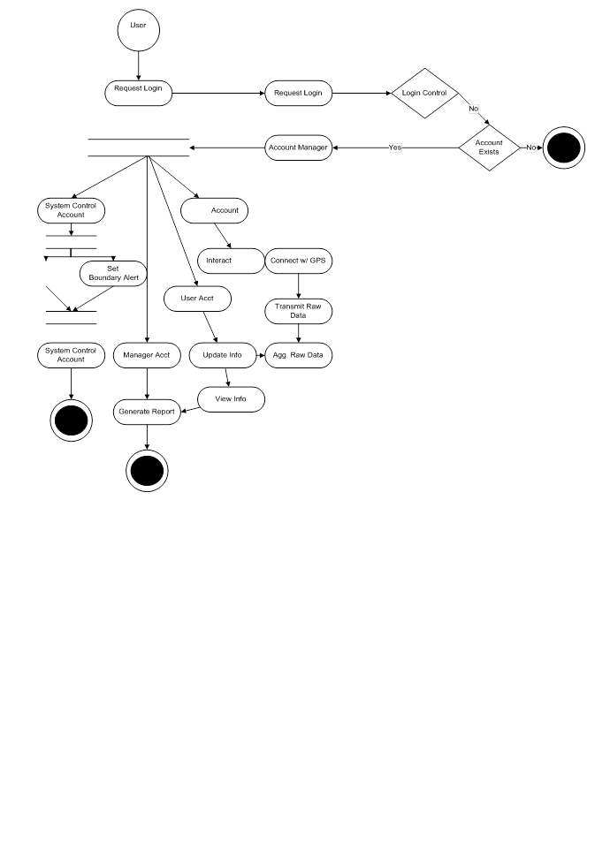

Figure -14

## Two Way Communication :



Figure -15

1. **SYSTEM TESTING :**

System testing of software or hardware is testing conducted on a complete, integrated system to evaluate the system's compliance with its specified requirements. System testing falls within the scope of black box testing, and as such, should require no knowledge of the inner design of the code or logic.

As a rule, system testing takes, as its input, all of the "integrated" software components that have successfully passed integration testing and also the software system itself integrated with any applicable hardware system(s). The purpose of integration testing is to detect any inconsistencies between the software units that are integrated together (called assemblages) or between any of the assemblages and the hardware. System testing is a more limited type of testing; it seeks to detect defects both within the "inter-assemblages" and also within the system as a whole.

5 **Testing**

**5.1 Introduction**

Till now the database design, user interface design and implementation are complete. The system now is tested for its functionality, validity and performance. In order to test the system, a wide variety of tests are conducted to make sure that the system matches the entire identified user requirements and conscabts. This chapter focuses on testing the developed systems using different test strategies in order to verify its correctness and user acceptance.

Testing is a process of executing a program with the intent of finding an error. A good test case is one that has a high probability of finding an as yet undiscovered error. A successful test is one that uncovers an as yet undiscovered error.

The development of software systems involves a series of production activities where opportunities for injection of human fallibility are enormous. Errors may begin to occur at the very inception of the process where the objectives may be enormously or imperfectly specified, as well as in later design and development stages. Because of human inability to perform and communicate with perfection, software development is accompanied by a quality assurance activity.

Software testing is a critical element of software quality assurance and represents the ultimate review of specification, design, and coding. And it needs to be done in almost every phase of product development life cycle not just before a product is handed to a customer.

The following are some attributes of a good test:

* A good test has a high probability of finding an error. To achieve this goal the tester must understand the software and attempt to develop a mental picture of how the software may fail. Ideally the classes of failure are probed.
* A good test is not redundant: testing time and resources are limited. There is no point in conducting the test that has the same purpose as another test. Every test should have a different purpose.
* A good test should be best of breed. In a group of tests that have a similar intent time and resource limitations may militate for the execution of only a subset of these tests. In such cases the tester that has the highest likelihood of uncovering a whole class of errors should be used.
* A good test should be neither too simple nor too complex: although it is sometimes possible to combine a series of tests into one test case, the possible side effects associated with this approach may mask errors. In general each test should be executed separately.

**5.2 Types of testing**

**5.2.1 White Box Testing**

White box testing, sometimes called glass box testing is a test case design method that uses the control structure of the procedural design to derive test cases. Using white box testing methods, the software engineer can derive test cases that :

* Guarantee that all independent paths within a module have been exercised at least once.
* Exercise all logical decisions on their true and false sides.
* Execute all loops at their boundaries and within their operational bounds.
* Exercise internal data structure to assure their validity.

White box testing was performed at all levels of development of i-Admit. The coding team took all care to test the code and guarantee that it meets all the specifications as well as logically correct. All loops were tested and all internal data structures evaluated and verified.

**5.2.2 Black Box Testing**

It focuses on the functional requirements of the software. That is black box testing enables the software engineer to derive sets of input conditions that will fully exercise all functional requirements for a program. Black box testing is not an alternative to white box techniques. Rather it is a complementary approach that is likely to uncover a different class of errors than white box methods. Black box testing attempts to find errors in their following categories

* Incorrect or missing functions
* Interface errors
* Errors in data structures or external data base access
* Performance errors
* Initialization and termination errors.

Unlike white box testing, which is performed early in the testing process, black box testing is to be applied during later stages of testing.

Black box testing was performed with the application code of the software being developed to verify that it is functionally correct and gives appropriate output at different situations of inputs. It was also verified that the software takes a good care of exceptional conditions and errors are handled well and that the software does not crash.

A strategy for software testing integrates software test case design methods into a well-planned series of steps that result in the successful construction of software. In many ways, testing is an individualistic process, and the number of different types of tests varies as much as the different development approaches.

**5.2.3 Unit Testing**

Unit testing focuses verification effort on the smallest unit software design- the module. Using the procedural design description as a guide, important control paths are tested to uncover errors within the boundary of the module. The module interface is tested to ensure that information properly flows into and out of the program unit under test. The local data structure is examined to ensure that data stored temporarily maintains its integrity during all steps in algorithmic execution. Boundary conditions are tested to ensure that the module operates properly at boundaries established to limit or restrict processing. All independent paths (bases paths) through the control structure are exercised to ensure that all elements in a module have been executed at least once. And finally all error-handling paths are tested.

Application interface of our system was unit tested at all levels of implementation, right from start of code writing, to integrating the code with other modules. Every module was tested fully to check its syntax and logical correctness. Error handling was implemented into relevant modules so that the code doesn’t crash on errors.

**5.2.4 Integration Testing**

Integration testing is a systematic technique for constructing the program structures, while conducting test to uncover errors associated with interfacing, the objective is to take unit tested modules and build a program structure that has been dictated by design.

User interface of i-Admit was developed in modules. All of them were joined together to make the complete running application. While integrating these modules, integration testing was performed on them to verify that they meet all interfacing requirements and that they pass relevant information among themselves. In the end the complete program structure was tested to ensure interoperability of all the modules. 

**5.2.5 Validation Testing**

At the culmination of integration testing software is completely assembled as a package: interfacing errors have been uncovered and corrected and a final series of software tests – Validation Testing may begin. Validation can be defined in many ways, but a simple definition is that validation succeeds when software functions in a manner that can be reasonably expected by the customer. Software validation is achieved through a series of Black Box tests that demonstrate conformity with requirements.

**5.2.6 Security Testing**

Security Testing attempts to verify protection mechanism built into a system will in fact protect it from improper penetration.  Security is provided for each user by giving them login name and password. Security testing was done, as any other anonymous user can’t log in with a user password if the user is already logged in.

**5.2.7 Performance Testing**

Performance Testing is designed to test run time performance of software within the context of an integrated system. Performance Testing occurs throughout all steps in the testing process. Performance tests are often coupled with stress testing and often require both hardware and software instrumentation. That is it is often necessary to measure resource utilization in an exacting fashion. External instrumentation can monitor execution intervals, log events as they occur, and sample machines take on a regular basis. By instrumenting a system the tester can uncover situations that lead to degradation and possible system failure.

**6. OUTPUT:**

Global Positioning System to determine the precise location (Longitude & Latitude) of a vehicle, person, or other asset to which it is attached and to record the position of the asset at regular intervals. The recorded location data can be stored within the tracking unit, or it may be transmitted to a central location data base, or internet-connected computer, using a cellular (GPRS or SMS), radio, or satellite modem embedded in the unit. This allows the asset's location to be displayed against a map backdrop either in real time or when analyzing the track later.

**7. CONCLUSION & FUTURE ENHANCEMENT**

A GPS also known as a Global Positioning System is a great technology that is used to track objects around the world. The technology was developed by the US military in an attempt to make success more seamless for the military – this technology is now being used all over the world and it is highly reliable that it is very clear that this technology will be of more importance in the near future. You might hear about the latest GPS tracking system making the buzz or who made or is using the technology most but the fact is, what matters most isn’t the origin of the technology or who uses it but what is in it for you. There is no point in using something if you won’t be gaining anything from it. Many companies use GPS fleet tracking software with their service employees and this has helped them reduce fuel costs and increase work productivity. Below are some major advantages of using a **GPS tracking system**.

Advantage:

GPS Tracking System Can be Used to Locate Lost Items:

The crime rate keeps on increasing in every part of the world and a lot of highly valuable objects have been, and will, be stolen. It doesn’t matter how irrelevant you think an object or equipment is to others if it is something that is very expensive you should make sure you install a GPS tracking system on it; for example, a $2 million violin was once stolen from a café in London and the owner had a hard time finding it, if the owner of this highly expensive violin had installed a GPS tracking system in her violin it will be very easy for her to locate it.

It is almost impossible to reduce the crime rate in the world because new technologies are emerging and it is new technologies that encourage crime and stealing; however, you can make it easier for you to track any valuable object you own by installing a GPStrackerinit.  
  
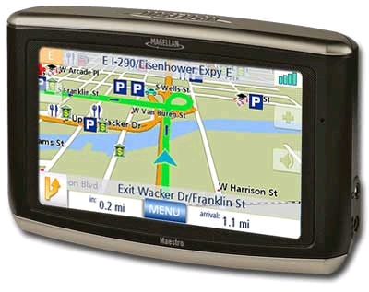

GPS Tracking System Can be Used to Track Things and People:

One great function of a GPS tracking system is that it can be used to track anything irrespective of it being static or flexible, it can also be used to track people and animals depending on what you need it for. Another great feature of a GPS tracking system that makes it better is the [alarm system it has](http://techgyo.com/index.php/5-free-android-apps-one-must-install/); for example, you can easily install a GPS tracking system in a vault where valuable goods are so that you can be alarmed anytime someone is trying to steal them. You can also use the GPS [technology](http://techgyo.com/index.php/how-to-map-the-location-or-picture-in-g-o-o-gle-earth-2/) to ensure things are going fine with people working for you especially if they’re doing a job that requires a high level of security and confidentiality; this will be able to track them anywhere they go and when they go there.  
  
 GPS Tracking System Can be Used Anywhere in the World:

An added advantage of the GPS tracking system is that it can be used anywhere in the world; it doesn’t matter whether you’re in Africa or Asia the GPS technology is powered by the world satellites and this means it can be accessible anywhere; all you need is a solid tracking system and a GPS receiver.

**Disadvantages**:

* Sometimes the GPS may fail due to certain reasons and in that case you need to carry a backup map and directions.
* If you are using GPS on a battery operated device, there may be a battery failure and you may need a external power supply which is not always possible.
* Sometimes the GPS signals are not accurate due to some obstacles to the signals such as buildings, trees and sometimes by extreme atmospheric conditions such as geomagnetic storms.

**Benefits:**

* Benefits include the prevention of labor fraud, speeding, idling, unauthorized vehicle usage, and more. Here are a few of the most common benefits immediately experienced by GPS Insight clients.
* For parents, it takes some of the worry out of your kids driving long distances home from college. You know where they are and when to expect them home.
* For baby-boomers, the shoe is on the other foot - it helps to take some of the worry out of your elderly parents driving home from vacation or just driving around town. You know where they are and this allows them to be more independent.
* GPS tracking is customer service at its finest. You know instantly which of your drivers is closest to the customer needing help.
* Imagine how thrilled your customers will be when you can tell them exactly when to expect their delivery!
* For employers, using GPS tracking allows you to know how fast your employees are driving, how long a break they are taking (vehicle hasn’t moved), and if they are where they say they are!
* GPS tracking also allows you to monitor fuel usage based on how fast your employee is driving and the automatic mileage feature reminds you to schedule, regular preventative maintenance.
* GPS tracking is customer service at its finest! You know instantly which of your drivers is closest to the customer needing help. And Imagine how thrilled your customers will be when you can tell them exactly when to expect their delivery!
* GPS Tracking can eliminate the need for having your truckers fill out driving logs.
* Many insurance companies now offer discounts for vehicles protected with tracking systems.

Advancement in GPS tracking system:

As global positioning technology continues to evolve, so too is the GPS tracking software often used with many GPS tracking devices.  With the combined power of the Internet, and computer and satellite technology, GPS tracking software for use with any GPS tracking device has grown to include more options than ever before.  Below you will find highlights of the latest features and advancements in the industry of GPS tracking software.

Real-Time Updates:

Depending on the GPS tracking device used, GPS tracking software can provide real-time, on screen reporting on the specific location of a person, parcel or vehicle from any location in the world.  This particular feature of GPS tracking software has provided a cost-effective GPS tracking solution for several industries including aviation, shipping and commercial fishing, where a GPS tracking device can likely be found attached to every company asset.

Mapping:

Once considered to provide only crude renditions of the actual terrain, the mapping capabilities of GPS tracking software have improved greatly over the last few years.  With many types of GPS tracking software fully integrating with readily available resources such as Google Earth and Microsoft Virtual Earth, GPS tracking software can now provide detailed real photo maps of the location of any GPS tracking device.In addition, some GPS tracking software applications will now accommodate the use of customized digital, paper or marine maps in the event that standard mapping options do not provide the needed details.

Simultaneous Tracking:

GPS tracking software can now be used to track and map the location of more than one GPS tracking device at a time.  Using highly- sophisticated technology, GPS tracking software now offers the ability to see an entire fleet of vehicles, given that each one is fitted with a GPS tracking device, on one screen.

Web Applications:

As the speed of Internet connections continues to increase, the ease of offering online-based GPS tracking software does as well.  Some providers of GPS tracking software are now offering web-based access to GPS tracking software for a monthly subscription or yearly licensing fee.  One major advantage of web-based GPS tracking software is that the software is constantly updated by the provider, leaving little or no maintenance for the subscriber to be concerned with.

In addition, some providers of web-based GPS tracking software will allow private-branding of their applications so that licensees can sell subscriptions to their own customers.  This presents a unique opportunity for any GPS tracking device dealer or entrepreneur who wants to create residual monthly income based on selling GPS tracking software subscriptions to the customer who purchases a GPS tracking device.

GPS tracking software and GPS tracking devices, like most other forms of technology including computers and cell phones, have experienced great advancements in the last decade. As the cost of the average GPS tracking device continues to decline, GPS tracking is becoming more affordable and in demand for individuals and small businesses than ever before, making GPS tracking and GPS tracking software one of the smartest business choices of the 21st Century.

**8. BIBLIOGRAPHY**

<https://www.sparkfun.com/tutorials/173>

<http://www.seeedstudio.com/wiki/GPRS_Shield_V2.0>

<http://www.seeedstudio.com/forum/viewforum.php?f=10&sid=823df9a5e63392b64eb0e93ea4843b6f>